Rolling Agenda and Notes -- VUG Steering Committee Meeting

Link to BlueJeans https://bluejeans.com/2489653490

Reference Documents
- Notes from June 14 meeting: https://docs.google.com/document/d/1YROboU4exPqldVnArexYQ5H-OZdkr6md3j0kofopvMw/edit
- Notes from April 24 meeting: https://docs.google.com/document/d/1zrGPwkpoKGSkAG18Z-cyLmHJjda_BHvJ7eRL6HQ3fPM/edit
- Notes from March 22 meeting:
https://docs.google.com/document/d/1ktEEXxEgFom6WywxF-XjTe05XmNlrUuUJ2YAoMz9iNA/edit
- Notes from January 17 meeting: https://docs.google.com/document/d/12n-A0psfoR0EXMzPNlYpzkspobvwniFaYtoM6eL1d9w/edit?usp=sharing
- Potential outstanding issues with Vireo 4 (https://github.com/TexasDigitalLibrary/Vireo/projects/19)
- Draft Schedule: https://drive.google.com/open?id=10kw2VL4qmEqM8iZZyD9YSCfftimPTmVj
- Vireo Documentation: https://texasdigitallibrary.atlassian.net/wiki/spaces/VUG/pages/87490693/Documentation+--+Vireo+4.0
- Vireo end user tasks for 2/18/2019 - 3/8/2019 Community Sprint: https://texasdigitallibrary.atlassian.net/wiki/spaces/VUG/pages/871464961
- Vireo end user tasks for future Community Sprint: https://texasdigitallibrary.atlassian.net/wiki/spaces/VUG/pages/886407170/Vireo+end+user+tasks+for+future+Community+Sprint

Agenda -- August 16, 2019

- Next Sprint begins on August 19
- Feedback needed from Frank about the following
  - Status of Deployment Documentation: https://github.com/TexasDigitalLibrary/Vireo/wiki
  - TAMU customizations: https://drive.google.com/file/d/11Nw4MXI0euk_qzTyPVmd0tHAyq_ItBPB/view?usp=sharing
  - James’ technical Override docs - both Stephanie and Chris added some ‘human’ language that is more user-oriented; SL making another document that is more plain English for Confluence (by mid-August). Where would James’ version best fit into github?
  - Webinar – intro shared with Chris- what’s the plan?
  - Migration development schedule
- Piloting Vireo 4
  - Texas Tech (hosted by TDL)
  - UT Southwestern Medical
  - University of Houston (limited testing)
- Tabled for future meeting
  - Pull request process
  - Slack channel management
Agenda -- July 12, 2019

Present: Stephanie Larrison, Billie Peterson-Lugo, Courtney Mumma, Kristi Park, Chris Starcher

Regrets: Emily Wuchner, Frank Smutniak

- Update on June sprint - almost all was accomplished and demoed on 7/3: Unfinished issues include
  - 1269 (Bug where Embargo edits will not save and no error msg is displayed)
  - 1158 (Deployment documentation) Steph erroneously thought the READ ME file was the deployment documentation. READ ME was updated but there is more to do
    - Frank working on it. This will be in github.
    - https://github.com/TexasDigitalLibrary/Vireo/wiki -- this will be the home for development and migration documentation; FS is in progress
  - 842 (Code comments/ JavaDocs) this was originally placed on the mid-August release - Kevin prioritized
  - In addition, TAMU demoed a customization for statuses and states which they made for their institution and requested that it be added to master branch. Discuss with VUG SC. Link to details
    - May consider for 4.1
    - CM to get info from Frank about impact of inclusion of this functionality - for review in next meeting
    - KP - this brings up questions about pull requests from the VUG community; need process for this
- User documentation - Everything except these sections are now publicly available: Override and Sync w/Parent; File Export Types, ProQuest Export Documentation, Copy of Hierarchical Organization Management (internal, will be deleted eventually)
  - File Export Types is waiting until it’s all working
  - ProQuest Export also just requires minor fix
  - Hopefully these will all be publicly available with August release
  - James documented Override docs - both Stephanie and Chris added some ‘human’ language that is more user-oriented; SL making another document that is more plain English for Confluence (by mid-August)
    - CM to ask Frank where James’ version would best fit in github
- Plan for webinar date and/or videos
  - would August 20 (Tuesday) work for webinar? The August release should be completed by then.
    - Length? Audience? What to cover?
      - 1.5 hours, 130PM - 3PM
      - Intro to Vireo (brief) - Chris and Frank
      - Shortened TCDL workshop - what’s new in Vireo 4 - Stephanie
  - CM to set up registration and webinar, promote to VUG
- DSpace export - embargo retention? FS embargo date present in current dspace export - will test import to dspace; was an issue that may have been resolved already? - Resolved
- Vireo License - Resolved with 1289 and released
- Sprint for go-live Mid-August - need FS for input into this
  - TAMU participation? Need to verify
- Vireo 4 migration strategy
  - Identify a couple of TDL institutions to work with Vireo 4 in fall 2019
    - Texas Tech
    - U of H can run in parallel but not ready for migration until at least Spring
    - UT Southwestern expressed interest at VUG meeting at TCDL
      - CM will reach out to confirm
  - Outline for TDL migration strategy
    - TDL (end of summer) will install Vireo 4 in parallel to current production version Vireo 3.x at institution
    - Institution (fall)
      - identifies one unit participant to use Vireo 4 in production as ETD submission system for Fall submissions
      - sets up Vireo 4 to facilitate the production workflow
      - reports bugs/issues to Vireo 4 github, TDL helpdesk or via the user group
    - TDL (after fall submissions are complete) will migrate Vireo 3.x content to Vireo 4 production instance
      - Frank will extract new data from Vireo 4 instance; migrate Vireo 3 data; and then update with extracted Vireo 4 data
    - TDL will run Vireo 3 and Vireo 4 in parallel for the time being
    - Institution (Jan/Feb) will share experiences with the rest of the TDL membership during a webinar
    - Migration - users, submissions, and action logs are the three things that would be migrated from the database in Vireo 3, everything else will need to be set up again; Settings don’t come over
      - SL is interested in more information about what comes over in the ‘submissions’ and specifically the embargo’d info
    - TAMU migration plans? Ask in Vireo Slack
    - TX State wants to migrate Honors program as pilot in the fall; but if Frank completes migration documentation by mid-August release, TX State would like to test
    - KP suggested an informal WG to coordinate migration testing
  - Training videos
    - Defer to fall
    - Shelly Barba may be available/willing to help with the videos
  - Schedule for development of migration (Frank) - defer to next meeting
  - August meeting? 16th at 930
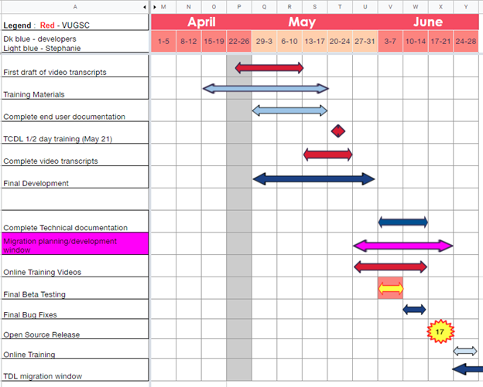

Begin | End | Task | Assigned | Notes
4/16/2019 | 5/17/2019 | Training Materials | Stephanie | Agenda -hands on creation of parent/ child orgs, customizing workflows, editing field profiles, assigning controlled vocab
4/24/2019 | 5/10/2019 | First draft of video transcripts | SC | 16 scripts to edit
4/24/2019 | 5/31/2019 | Final development | Frank and ? | As of 4/23/19 development requested for issues labeled Next (13) ; In Progress (7) ; Review (6)
4/29/2019 | 5/17/2019 | Complete end user documentation | Stephanie
5/13/2019 | 5/24/2019 | Complete video transcripts | SC
5/21/2019 | 5/21/2019 | TCDL 1/2 day training | SL, CC, CM | CC & CM to assist attendees with hands on exercises
5/28/2019 | 6/14/2019 | Online Training Videos | SC | 16+ to create
5/28/2019 | 6/26/2019 | Migration planning/development ?? | CM &KP begin. Frank and ? after open source release | Kristi took her vacation, so we’re meeting on the 23rd to outline our plan and will update the group that week.
6/3/2019 | 6/7/2019 | Final Beta Testing Window |  | Will any more testing be required after current TAMU sprint? - Not necessary
6/3/2019 | 7/1/20199 | Complete Technical documentation | Frank and TAMU | What is outstanding?
6/10/2019 | 7/1/2019 | Final Bug fixes | Frank
6/17/2019 | 7/1/2019 | Open Source Release | Frank
6/17/2019 | 8/16/2019 | TDL migration window |  | This would only be for one pilot migration
 | 8/16/2019 | Go Live release
6/17/2019 | 8/16/2019 | Online Training | Stephanie
9/1/2019 | 4/1/2020 | Migrations of TDL Vireo members

