VUG Steering Committee Meeting -- April 24, 2019

Link to BlueJeans https://bluejeans.com/2489653490

Present: Stephanie Larrison, Courtney Mumma, Frank Smutniak, and Chris Starcher

Regrets: Billie Peterson-Lugo, Kristi Park, Emily Wuchner

Reference Documents
- Notes from January 17 meeting: https://docs.google.com/document/d/12n-A0psfoR0EXMzPNlYpzkspobvwniFaYtoM6eL1d9w/edit?usp=sharing
- Notes from March 22 meeting:
https://docs.google.com/document/d/1ktEEXxEgFom6WywxF-XjTe05XmNlrUuUJ2YAoMz9iNA/edit
- Draft Schedule: https://drive.google.com/open?id=10kw2VL4qmEqM8iZZyD9YSCfftimPTmVj
- Vireo Documentation: https://texasdigitallibrary.atlassian.net/wiki/spaces/VUG/pages/87490693/Documentation+--+Vireo+4.0
- Vireo end user tasks for 2/18/2019 - 3/8/2019 Community Sprint: https://texasdigitallibrary.atlassian.net/wiki/spaces/VUG/pages/871464961
- Vireo end user tasks for future Community Sprint: https://texasdigitallibrary.atlassian.net/wiki/spaces/VUG/pages/886407170/Vireo+end+user+tasks+for+future+Community+Sprint

Agenda

- Action Items from March 22 meeting
  - Shelley from Texas Tech is willing to test the export issue once it’s been resolved
    - Holding –Steph doesn’t believe Shelley uses it and need to find someone who actually does.
    - Updated DSpace Simple export was sent to Colleen for Review. It needs a lot of edits to conform with Metadata Guidelines from the working group.
      - Most changes are straightforward/simple, but S is gathering all info before creating a github issue with the comprehensive mapping
  - Kristi and Courtney have a meeting with personnel from Trinity next week and may bring up Vireo testing with them
    - KP and CM - CM to verify export - they are not good testers for now because of changing internal processes and systems; not batch, 1 by 1
    - From meeting notes “Export is done one by one, then ingested one by one into Digital Commons; multiple collections of theses demands current process”
  - Stephanie will discuss the advisor/batch comment issue with James Creel to see if we can default to the functionality that currently works in Vireo; i.e., will it work if constrained to one advisor (instead of multiple advisors)
    - Created issue #1231 - JC has updated; business rules must be documented and in place at time of release
    - Needs to be ready by summer deployment
  - Chris will investigate the issue of students not receiving the initial submission e-mail message and whether or not that issue is connected to #1122 and #1123
    - Email workflows are working. 1122 and 1123 did not affect it.
    - FS will review 1122 and 1123 - ACTION
  - Prior to the next meeting, Courtney will look at the current Vireo software license and provide some recommendations of other types of licenses to consider
    - Current license is probably a BSD 2-Clause "Simplified" or "FreeBSD" license – Not MIT license.
    - Other Open Source licenses here: o https://opensource.org/licenses
    - Currently Vireo 4.0 github does not have a license file
      - Defer to FS - needs consulting with TAMU, Tech, VUG
      - CS - Weaver might have a different license; other dependencies might have different licenses
      - CS - Was originally an IMLS grant, might need to take that into consideration (consult with KP)
    - Needs to be completed/documented by the open source
- VUG Workshop at TCDL -- Only 2 registrants for the workshop so far
  - Please promote to the VUG and your colleagues.
    - Steph to draft and CM to finalize and send a reminder
  - Frank working on multi-user tests to prepare for the workshop up to 15 people.
    - Working on consistent deploy and persistent data
    - Protractor automated - signing in, creating institution/dept, creating a submission, processing
      - Need to work on multi-user and multi-account
      - CS - CLI allows you to load dummy submissions into the DB; might be simple to add in users similarly - FS will review
        - CLI java file; boot with specific flag, follow prompt to create x# records
- Discussion
  - Frank – Is there a decision on project board to replace Wafflio (ends on May 16)?
    - Focusing on the Waffle provided recommendations and migration paths
    - In Github, projects are detached from repository; cannot assign points, you must instead use tags
    - Should SL continue adding issues where she is currently?
      - FS will review and update SL and VUGSC by May 8
  - Chris – Can you identify any other developer or technical bugs in GitHub that are critical for use of Vireo on first release and add the Next label? If Administrator can manually change something, it can wait.
    - SL has marked issues she sees as necessary to dev (marked with NEXT tag in Waffle)
      - 7 in progress
      - 6 in review
    - Are there other dev-specific criticals? CS review request
      - If an admin can change something, those can wait
    - FS Might be items in progress which haven’t been moved - will update/clean up
      - Will also review simple issues in NEXT
      - Some Review column items ready for SL feedback
    - All bugs should be fixed by May 31 (everything with NEXT tag from Review and In Progress)
  - Migration strategy/development
    - When should migration strategy and development occur?
      - Don’t need to have the migration strategy solidified prior to the OS release
      - FS advises release even if migration strategy isn’t ready so that folks can use it/test it
    - TxState will help test migration.
  - Updated schedule proposed (see schedule details below)
    - Overlapping dates for different tasks were reduced as much as possible.
    - Are these new dates realistic?
      - Changed OS release for Monday, June 17th
        - FS currently says this is possible, but requires a little more time with the remaining issues in progress
          - FS f/u about TAMU and Tech dev commitment
        - TDL needs time to migrate TDL folks with as much time as possible - mid-June to mid-August and potentially another in Fall
      - FS - please update VUG SC with vacation dates

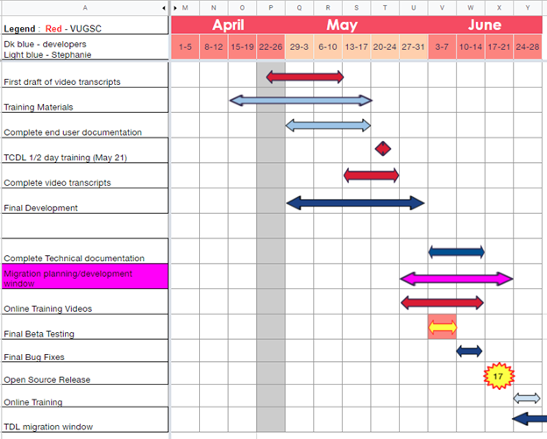

Begin | End | Task | Assigned | Notes
4/16/2019 | 5/17/2019 | Training Materials | Stephanie | Agenda -hands on creation of parent/ child orgs, customizing workflows, editing field profiles, assigning controlled vocab
4/24/2019 | 5/10/2019 | First draft of video transcripts | SC | 16 scripts to edit
4/24/2019 | 5/31/2019 | Final development | Frank and ? | As of 4/23/19 development requested for issues labeled Next (13) ; In Progress (7) ; Review (6)
4/29/2019 | 5/17/2019 | Complete end user documentation | Stephanie
5/13/2019 | 5/24/2019 | Complete video transcripts | SC
5/21/2019 | 5/21/2019 | TCDL 1/2 day training | SL, CC, CM | CC & CM to assist attendees with hands on exercises
5/28/2019 | 6/14/2019 | Online Training Videos | SC | 16+ to create
5/28/2019 | 6/14/2019 | Migration planning/development ?? | CM &KP begin. Frank and ? after open source release
6/3/2019 | 6/7/2019 | Final Beta Testing Window
6/3/2019 | 6/14/2019 | Complete Technical documentation | Frank and ?
6/10/2019 | 6/14/2019 | Final Bug fixes | Frank and ?
6/17/2019 | 6/17/2019 | Open Source Release | Frank and ?
6/17/2019 | 8/16/2019 | TDL migration window
6/17/2019 | 8/16/2019 | Online Training | Stephanie

