VUG Steering Committee Meeting -- June 14, 2019

Link to BlueJeans https://bluejeans.com/2489653490

Present: Stephanie Larrison, Billie Peterson-Lugo, Courtney Mumma, Frank Smutniak, and Chris Starcher

Regrets: Kristi Park, Emily Wuchner

Reference Documents
- Notes from April 24 meeting: https://docs.google.com/document/d/1zrGPwkpoKGSkAG18Z-cyLmHJjda_BHvJ7eRL6HQ3fPM/edit
- Notes from March 22 meeting:
https://docs.google.com/document/d/1ktEEXxEgFom6WywxF-XjTe05XmNlrUuUJ2YAoMz9iNA/edit
- Notes from January 17 meeting: https://docs.google.com/document/d/12n-A0psfoR0EXMzPNlYpzkspobvwniFaYtoM6eL1d9w/edit?usp=sharing
- Draft Schedule: https://drive.google.com/open?id=10kw2VL4qmEqM8iZZyD9YSCfftimPTmVj
- Vireo Documentation: https://texasdigitallibrary.atlassian.net/wiki/spaces/VUG/pages/87490693/Documentation+--+Vireo+4.0
- Vireo end user tasks for 2/18/2019 - 3/8/2019 Community Sprint: https://texasdigitallibrary.atlassian.net/wiki/spaces/VUG/pages/871464961
- Vireo end user tasks for future Community Sprint: https://texasdigitallibrary.atlassian.net/wiki/spaces/VUG/pages/886407170/Vireo+end+user+tasks+for+future+Community+Sprint

Agenda

- TAMU sized with Frank this week, sprint begins next Monday with goal to release July 1
  - Stephanie helped to distinguish between release requirements and ‘go live’ requirements
  - Sizing with Frank and TAMU - 11 items, only 7 not started, 3 about documentation, 4 are ‘bugs’
  - Stephanie asks for beta testing rather than July 1 release
    - VUG - small subgroup of testing; usually don’t test deployment
    - Direct outreach strategy
    - Frank - largely haven’t added features, rapid deployments
    - Chris agrees to skip beta tests for now; save user group for more valuable time
    - Billie - sees what we did at TCDL as testing for the release
- Goal to finish up user documentation by July 1 as well
  - Kristi available to help when she gets back from vacation
  - Stephanie says it’s mostly done - Proquest is outstanding, but largely the same as before; need to explain override and workflow steps; using sync with parent - define and describe use
- Online training and/or videos
  - Need to update scripts - July
  - TXETDA opportunity to present Vireo in the fall of 2019 (or when Stephanie is ready)
- Potential outstanding issues with Vireo 4 (see also https://github.com/TexasDigitalLibrary/Vireo/projects/19)
  - Export issue (see April agenda) Resolved for DSpace simple export format
  - Advisor/batch comment issue (see April agenda) FSS Nearly complete - included in next sprint
  - Students not receiving initial submission e-mail message; FS will review 1122 and 1123 (see April agenda) Resolved/Delayed
  - Vireo software license (see April agenda)
    - Weaver has the MIT license
    - Current license is BSD 2-Clause "Simplified" or "FreeBSD" license
    - Discuss/consider GPL 2.0 - free to use, and any modified versions must also be freely available. This means modified versions can be sold, but the modified code must be freely available.
      - Justifiable since Vireo 4 is an end-product
      - Protects us
    - Frank recommending MIT license for everything -
    - Do we need to create an issue to start a license file?
      - Will just be part of the github -- CM to do
    - For reference: https://en.wikipedia.org/wiki/License_compatibility, https://opensource.org/licenses
  - “Wobbliness” of Vireo during workshop at TCDL
    - An issue arose that is part of the current sprint - hanging modal
- Update on the status of Vireo 4 development since April meeting and TCDL
  - (see also https://github.com/TexasDigitalLibrary/Vireo/projects/19)
- Vireo 4 release and migration strategy after VUG meeting at TCDL
  - FS advises release even if migration strategy isn’t ready so folks can use/test it
  - Texas State will help test migration
  - Updated schedule (see April agenda for notes)
  - Frank working with TAMU over the next week to figure out exactly what needs to be migrated and document it - Slack and Confluence documentation as a result
  - KP and CM meeting about services in a week and discussing Vireo migration is part of that
- Testing
  - Need to test DSpace export - embargo retention? FSS embargo date present in current dspace export - will test import to dspace.
    - Was an issue that may have been resolved already
  - Courtney, Billie and Stephanie to work on draft release email

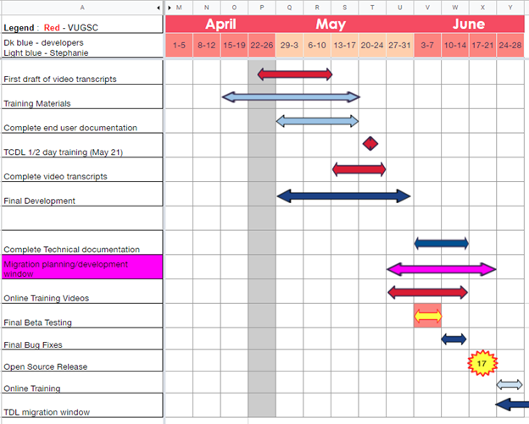

Begin | End | Task | Assigned | Notes
4/16/2019 | 5/17/2019 | Training Materials | Stephanie | Agenda -hands on creation of parent/ child orgs, customizing workflows, editing field profiles, assigning controlled vocab
4/24/2019 | 5/10/2019 | First draft of video transcripts | SC | 16 scripts to edit
4/24/2019 | 5/31/2019 | Final development | Frank and ? | As of 4/23/19 development requested for issues labeled Next (13) ; In Progress (7) ; Review (6)
4/29/2019 | 5/17/2019 | Complete end user documentation | Stephanie
5/13/2019 | 5/24/2019 | Complete video transcripts | SC
5/21/2019 | 5/21/2019 | TCDL 1/2 day training | SL, CC, CM | CC & CM to assist attendees with hands on exercises
5/28/2019 | 6/14/2019 | Online Training Videos | SC | 16+ to create
5/28/2019 | 6/26/2019 | Migration planning/development ?? | CM &KP begin. Frank and ? after open source release | Kristi took her vacation, so we’re meeting on the 23rd to outline our plan and will update the group that week.
6/3/2019 | 6/7/2019 | Final Beta Testing Window |  | Will any more testing be required after current TAMU sprint? - Not necessary
6/3/2019 | 7/1/20199 | Complete Technical documentation | Frank and TAMU | What is outstanding?
6/10/2019 | 7/1/2019 | Final Bug fixes | Frank
6/17/2019 | 7/1/2019 | Open Source Release | Frank
6/17/2019 | 8/16/2019 | TDL migration window |  | This would only be for one pilot migration
 | 8/16/2019 | Go Live release
6/17/2019 | 8/16/2019 | Online Training | Stephanie
9/1/2019 | 4/1/2020 | Migrations of TDL Vireo members

